Wright or Wrong
Wright Brothers National Memorial

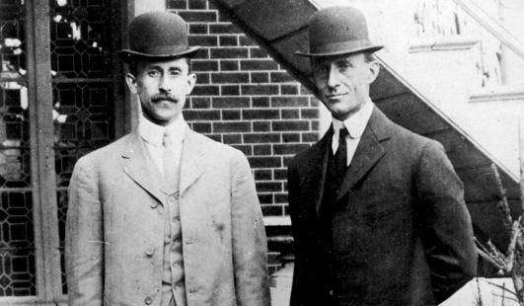
Location: In-class
Grade: 8th grade
Subject: English Language Arts
Duration: 60 minute/ 1- class period
Key Vocabulary: resources, citation, debate
North Carolina State Standards:
RL.8.1: Cite the textual evidence that most strongly supports an analysis of what the text says explicitly as well as inferences drawn from the text.
S.L. 8.4: Present claims and findings, emphasizing salient points in a focused, coherent manner with relevant evidence, sound valid reasoning, and well-chosen details; use appropriate eye contact, adequate volume, and clear pronunciation.

Materials:
index cards
Computer/Internet access
stop watch
Site Significance:
The park is an active educational resource offering unique opportunities for students to determine the significance of the Wright brothers achievements at Kitty Hawk, NC.
Objectives: The student will be able to: a) cite sources that validate an argument, b) use appropriate citation for sources used during their argument development, c) present a convincing argument in a clear and concise manner that validates an argument.
Essential Question: What documentation and sources can be used to verify that the Wright brothers were truly the first to achieve controlled and sustained flight?
Method: Students will debate two points-of-view in order to verify that the Wright brothers were the first to achieve flight on December 17,1903 at Kitty Hawk, North Carolina.
Background: In recent years an argument has commenced that the Wright brothers were not the first to achieve to flight. The following website gives additional information about the rivalry between Langley and the Wright brothers: https://www.npr.org/templates/story/story.php?storyId=1469463
The rivalry between Dr. Samuel Langley of the Smithsonian Institute and Wilbur and Orville Wright would continue for years to come and was an important aspect of the race to achieve first flight.
** It is up to teacher discretion whether to share the background information about Langley vs. Wright with the students or to let them discover the information through independent research.

Suggested Procedure:
Before class write the number 1, 2, or 3 on slips of paper and put into a bowl. As students enter the classroom, have them choose a slip of paper from the bowl. This will determine which group they will work with during class. Each group will have a different role during the class period.
Lesson Introduction (20 mins): Teacher will introduce facts and videos about the Wright brothers and their achievement of sustained, controlled flight at Kitty Hawk, NC on December 17, 1903. Teacher will then present the argument that has evolved in recent years that flight had been achieved prior to 1903, by others besides the Wright brothers. Students will then disperse into their groups and begin to research and develop and argument about the achievement of first flight by the Wright brothers at Kitty Hawk, North Carolina. Teachers can utilize the following resources to help introduce the lesson:
http://www.wright-brothers.org/History_Wing/History_of_the_Airplane/Who_Was_First/Who_Was_First_Intro/Who_Was_First_Intro.htm
https://www.youtube.com/watch?v=76K8d642CDE
Prior to students dispersing to formulate their debate argument the teacher will lead a discussion about reliable vs. unreliable resources. Students will be limited to using sites that have the distinction of .edu, .gov, or .org. Teacher can use the following video to help them understand how to determine if a resource is reliable or not.
https://www.youtube.com/watch?v=PLTOVoHbH5c

Debate Development (20 minutes): The class will divide-up based upon the numbers drawn at the beginning of class. Each group will take on a different role and research and present their findings in a debate format.
Group 1: Students in this group will develop an argument to validate that the Wright brothers were the first to achieve sustained, controlled flight at Kitty Hawk, North Carolina on December 17. 1903. They should focus their research and argument development on three specific areas (credible resource links can be found under “Websites”):
- (1) What events occurred from 1900-1903 that verifies that the Wilbur and Orville Wright achieved flight?
- (2) What documentation exists that validates the events that occurred at Kitty Hawk, North Carolina on December 17, 1903?
- (3) What arguments exist against the Wright brothers’ achievement and how can you argue against these claims?
Group 2: Students in this group will develop an argument to invalidate that the Wright brothers were the first to achieve sustained, controlled flight. They should focus their research and argument development around three specific areas (credible resource links can be found under “Websites”):
- (1) What claims exist that argue that others achieved first flight before 1903?
- (2) What documentation exists to validate these claims?
- (3) What evidence verifies that the Wright brothers were the first to achieve flight and how could these be debunked?
Group 3: This group will be the “jury” for the debate and will determine the winning argument. In order to understand their role in this exercise they should research debate rules, how to determine points during the debate, and how time limitations are used to help the debate process proceed. The following sources can be used in order for students to understand these concepts. The group should develop a points sheet that they will use during the debate to determine the winning argument.
https://www.edu.gov.mb.ca/k12/cur/socstud/frame_found_sr2/tns/tn-13.pdf
https://debate.uvm.edu/dcpdf/MSPDP.06.Judge.Instructions.And.Rubric.pdf
Evaluation Rubric: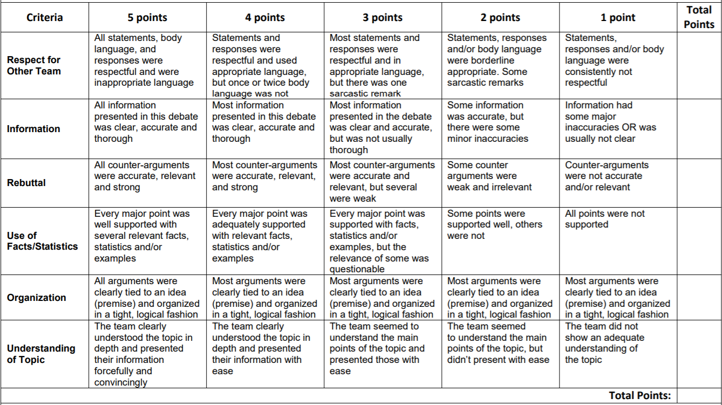

Concluding Questions:
- The “jury” (third group) will announce the winner of the debate and explain the reasons why more points were allotted to that particular team during the debate.
- Why do you feel that others claim to have achieved flight?
- What is the difference between powered flight and controlled flight?

Additional Resources
Websites:
https://airandspace.si.edu/exhibitions/wright-brothers/online/
http://www.wright-brothers.org/History_Wing/History_of_the_Airplane/Who_Was_First/Who_Was_First_Intro/Who_Was_First_Intro.htm
https://www.youtube.com/watch?v=76K8d642CDE
https://www.youtube.com/watch?v=PLTOVoHbH5c
https://www.edu.gov.mb.ca/k12/cur/socstud/frame_found_sr2/tns/tn-13.pdf
https://debate.uvm.edu/dcpdf/MSPDP.06.Judge.Instructions.And.Rubric.pdf
https://www.npr.org/templates/story/story.php?storyId=1469463

